Chapter 15, Problem 22.

Find the Laplace transforms of the functions in Fig. 15.34.

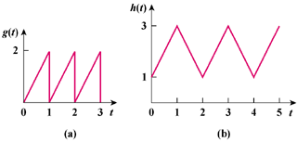

Figure 15.34
For Prob. 15.22.

